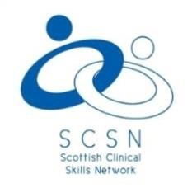
Scottish Clinical Skills Network Conference
Suttie Centre for Teaching & Learning in Healthcare
Foresterhill Campus
Aberdeen

20th & 21st April 2016

Provisional Programme
Fostering Collaboration Across Healthcare Networks
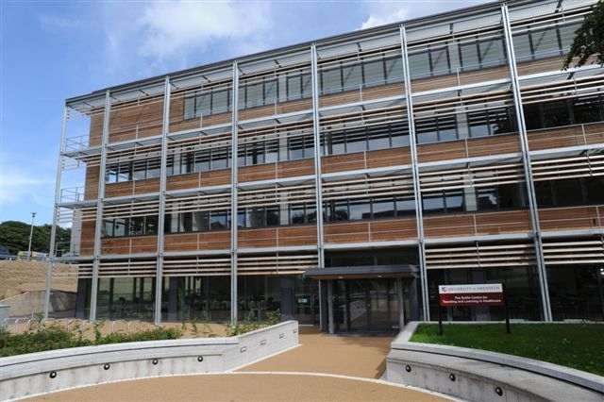

SCOTTISH CLINICAL SKILLS NETWORK CONFERENCE 2016

Wednesday 20 April 2016

DAY ONE
Time | What’s On | Venue
08.30 – 17:00 | Conference registration and delegate support | Reception Desk

Time | What’s On | Venue
08.30 – 09.30 | Registration Coffee and Pastries | Atrium, Suttie Centre
09.30 – 09.45 | Welcome & Opening Remarks | Lecture Theatre
 | Opening address by Dr Jerry Morse, Chair SCSN
09.45 – 10:45 | Plenary Keynote Address | Lecture Theatre
<<Insert title>> Alison Mackin
<<Insert presentation title>>
10.45 – 11.15 | Refreshments and viewing of Exhibition Area | Break Out Area & Ward

Time | What’s On | Venue
Workshops  11.15 – 12.15 | Laerdal  <<Insert title>>
Co Hosted by Jerry Morse, Michael Moneypenny, Andy Anderson & Rhoda MacKenzie
Developing collaborative standards in simulation across the networks
Whitehead KA, Lennie S <<note: from abstracts>>
The DIET-COMMS tool and training package: Developing and assessing communication skills for behaviour change in pre-and post-registration Dietitians.
 | <<invited workshop>>
 | Limbs & Things
12:15 – 14.00 | Lunch - Including Viewing of Exhibition Area & Posters  Poster Walk Day 1: 13.30 – 14.00 | Break Out Area & Ward
12.15 – 12.45 | Scottish Clinical Skills Network AGM | Lecture Theatre

14.00 – 15.30 | Short Oral Presentations | Sub rooms
 | Session 1 Student Presentations (6 presentations)
 | Session 2 Presentations (6 presentations)

Time |  | What’s On | Venue
PARALLEL SESSIONS | 15.30 – 16.30 | Laerdal
Paul Smith & Grant King
Workshop submission- Administering Intramuscular injections: bridging the theory practice gap?
L Hawick, E Stubbing, J Cleland
What shapes the curriculum and student development in healthcare education, an exploratory workshop
 |  | BD
Lysa Owen
“I don’t want to look like an idiot”. Anxiety, embarrassment and trickery in Simulation based education

16.30 | Round up of Day One | Lecture Theatre
18.30 for 19.00 -late! | Evening Social Event – Dinner & Beer Tasting | The Town House, King Street.

Thursday 21 April 2014
Day Two

Time | What’s On | Venue
08.30 – 17:00 | Conference registration and delegate support | Atrium, Suttie Centre

Time | What’s On | Venue
08.30 – 08.45 | Registration - coffee and pastries | Atrium, Suttie Centre
08.45 - 09.00 | Welcome & Opening Remarks | Lecture Theatre
 | Dr Jerry Morse, Chair SCSN
09.00 – 10.00 | Plenary Keynote Address | Lecture Theatre
<<insert title>> Mike Sabin
<<Insert presentation title>>

Time | What’s On | Venue
PARALLEL SESSIONS  10.00 – 11.00 | Laerdal
Dr Gloria Esegbona <<note from abstracts>>
Thinkinbox Model: How to foster healthcare collaboration across networks in 3 simple steps
Co Hosted by Jerry Morse, Michael Moneypenny, Andy Anderson & Rhoda MacKenzie
Developing collaborative standards in simulation across the networks
 | Limbs & Things
 | BD
11.00 – 11.30 | Refreshments, SIG meetings: Including Viewing of Exhibition Area & Posters | Break Out Area & Ward
11.30 – 13.00 | Oral Presentations
 | Session 1 Presentations (6) | <<insert venue>>
 | Session 2 Presentations (6) | <<Insert venue>>
13.00 – 14.00 | Lunch – Including Viewing of Exhibition Area & Posters  Poster Walk Day 2: 13.30 – 14.00 | <<Insert venue>>
14.00 – 15.00 | Moving Forward – Developing the Collaborations | Lecture Theatre
 | Dr Jerry Morse & Dr Michael Moneypenny and the New SCSN Vice Chair
15.00 – 15.30 | Round up of Day 2 & Prize Giving | Lecture Theatre

Presentations

Student Presentations: Session 1
Day 1: 20 April
14.00-15.30
Name | Title
Mr Samuel Kent | Should we add smells in simulation training? A systematic review of smells in healthcare related simulation training.
Laura MacDonnell | Developing a mobile application as a platform for clinical skills orientated peer-assisted learning.
Iain Rowe | The use of Lt, a cloud-based life science teaching system, for the development and delivery of on-line teaching and learning material on common clinical conditions for Pharmacist Independent Prescribers
Derek Scott (Best) | Simulators and renal physiology
Derek Scott (Kroll & Robertson) | Simulators, amiodarone and ALS
Derek Scott (Oskooi) | Simulators and anticholinergic burden

Oral Presentations: Session 2
Day 1: 20 April
14.00-15.30
Sharon Donaghy | Facilitating a Human Factors workshop at a Nursing, Midwifery and Allied Health Professional (NMAHP) symposium
Gayle Mackie | Turning the Tables on Operating Department Practitioner Students: Student Collaboration to Create Peer‐  Developed Scenarios
Tanya Somerville | Delivery of a simulation course specifically for anaesthetic assistants in to enhance leadership and team working skills and thereby empower anaesthetic assistants to aid the management of anaesthetic emergency situations within the operating department.
Gloria Esegbona | The smart rota (smartr): how to maximize clinical workplace learning
Ailsa Hamilton | The development of a behavioural marker system for medical students’ non-technical skills
Laura McGregor | experiences of SBME
Oral Presentations: Session 1
Day 2: 21 April
11.30 - 13.00
Craig Brown | Hot off the press: Evaluation of innovative education
Jerry Morse | Does Inter-Professional Education in Immediate Life Support training have an effect on team performance during simulated resuscitation?
Helene Marshall | Using Interactive books for learning
Fiona Fraser | Collaborate to Accumulate: Novel and progressive models of development for efficiency in care home and care at home support worker education.
Morag Howard | The use of simulation make up in undergraduate diagnostic radiography education
Gayle Mackie | The Growth and Development of a National Simulation Technician Community and Annual Collaborative Event

Oral Presentations: Session 2
Day 2: 21 April
11.30 - 13.00
Andrew Santos | Learning Together Prepares Students to Work Together
Kevin Garrity | Simulation Curriculum: Levelling the playing field?
Iain Rowe | The development and piloting of an on-line lesson on inhaler technique for undergraduate pharmacy students
Paul Smith | NEAREST: A new framework for improving the clinical skills of assessing and supporting people at risk of suicide
Susan Somerville | The use and impact of a mobile clinical skills and simulation facility in remote and rural Scotland – A realist synthesis and evaluation - work in progress
Cathy Carr | Does the use of a flipped VS traditional classroom in clinical skills teaching sessions maximise student interaction and practice time?
Poster Walk
Day 1: 20 April
13.30 - 14.00
Ailsa Armstrong | Title:- In-situ Theatre Team Training by Simulation - Raigmore Hospital.
Karen Hainey | Preparedness for Practice. Does a blended learning approach to teaching Central Venous Access Device (CVAD) care and maintenance prepare nurses for practice?
Fiona Fraser | Collaboration and shared understanding:  Case Studies demonstrating Quality Assurance approaches within Distributed Education, aiding access, inclusion and educational economy.
Andrea Baker | Creating excellence in a managed educational network
Smita Sinha | Review and innovation; the use of the tablets/mobiledevices in medical undergraduate education
Lorraine Hawick | Medical Student and Patient Experience Pilot Project
Fiona Logie | Using Volunteers to Develop a Volunteer Programme
Derek Scott (Arnott et al) | Stoma siting and cadavers
Brown C, Sinha S, Cooper A | The costs of teaching and assessing practical procedures
Gary Francis | Clinical Skills Peer Tutor Programme

Poster Walk
Day 2: 20 April
13.30 - 14.00
Jackie Reaper | The Aberdeen experience of the NES pharmacy project
Fiona Fraser | Video conferencing applications to establish a distributed educational  network: enhancing early referral of those with acute diabetic foot
Maureen Williamson | Simulation as a training tool for advanced nurse practitioners
Fiona Wark | Exploring the experiences and perceptions of midwife educators following a high fidelity birth simulator workshop: a phenomenolgical study.
Craig Brown | Simulation based education: Big Brother IS watching YOU!
Gloria Esegbona | How does art improve clinical learning?
Sharon Levy | Assessing advanced diagnostic skills and clinical decision making through online simulation
Fiona Fraser | Inclusion and access: collaborating to enhance networked engagement, skill maintenance and development; MBT and psychotherapeutic approaches
Derek Scott | OSPEs for biomed students
Derek Scott | Using iPads to assess biomed OSPE’s

